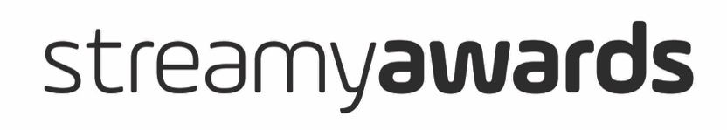
Streamys Brand Awards Submissions Template • 2019

ABOUT THIS DOCUMENT: This document is for reference purposes only. It is meant to be a tool for you to use to collect Submission information and then cut and paste it into the Submissions form on the Streamys site.

All Submissions must be made through the Streamys website. To access the submissions form – and for more information on categories, eligibility, and all other things Streamys – please go to Streamys.org/submissions.

This Submissions Template is for the Streamys Brand Awards. For more information on Submissions to the Streamy Awards and The Purpose Awards @ The Streamys please go to Streamys.org/submissions.

CONTACT: Please email submissions@streamys.org if you have any questions about the submissions process.

STREAMYS BRAND AWARDS ENTRY DEADLINES AND FEES:
Submission fees are a flat rate on a per project basis. This means the same project can be entered in to multiple categories under one submission fee. All deadlines end at 11:59PM PT.
- Early Deadline: July 26, 2019 - $295
- Regular Deadline: August 9, 2019 - $395
- Last Chance Deadline: August 16, 2019 - $495

INFORMATION YOU’LL NEED FOR SUBMISSIONS IN THE STREAMYS BRAND AWARDS: Below is a rough outline of the Streamys Brand Awards Submissions Form and a list of all the information you will need to complete your Submission. Please note the exact wording of what appears on the Streamys Submission form on the website may differ from the below, but the information you need to enter will not change.

Contact Information and Assets
Information on who is filling out the Submission
- Name
- Contact Email
- Title
- Company
- Mailing Address
- Phone Number
- Image Assets URL (A link to an image - or folder of images - the Streamys may use to promote your submission should it be nominated.)

Submission Information
Information and details about your Submission.
- Name
- Featured Brand
- Website or Channel URL
- Description and Objective (Please tell us a little bit about your entry, including the goals leading up to its implementation. 250 words max.)

- Strategy and Implementation (Describe the implantation strategy. 250 words max.)

- Results (Tell us the results of the campaign, including any key features that were particularly successful. 250 words max.) *

- Exemplary Video (You may include the URL of a video that highlights your entry in this category)
- Creators / Producers (The individuals, brands, agencies, and/or organizations that worked on the project.)
- Creators / Producers Contact Emails (This is so we can notify the Creators / Producers if the submission is selected to be a Streamys Honoree, Nominee, Finalist, and/or Winner.)

