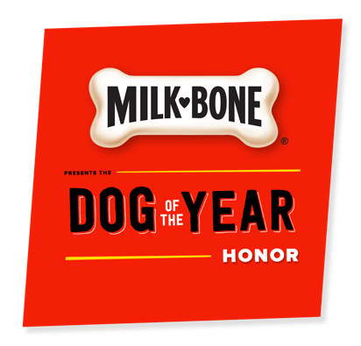
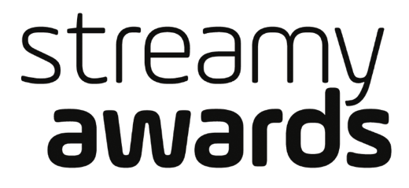

THE STREAMY AWARDS PARTNERS WITH MILK-BONE®
TO PRESENT THE FIRST-EVER
“MILK-BONE® DOG OF THE YEAR HONOR”
AT THE 8TH ANNUAL STREAMY AWARDS

The 8th Annual Streamy Awards Take Place
Monday, October 22, 2018 at 9PM ET / 6PM PT

For Streamy Awards photos and video assets, please go to: http://bit.ly/StreamysAssets18

Los Angeles (September 24, 2018) – dick clark productions announced today that the 8th Annual Streamy Awards will partner with Milk-Bone to present the first-ever “Milk-Bone Dog of the Year Honor” at this year’s show. The Streamy Awards will join forces with Milk-Bone to award one amazing dog with this special recognition. This honor celebrates bravery, overcoming obstacles, and strong personality and loyalty traits that make all dogs truly special. These qualities will be exemplified in three selected finalists, which will be announced on October 1st.

Submissions and fan nominations for the 8th Annual Streamy Awards are now closed. Fans will be able to vote for their favorite “Milk-Bone Dog of the Year Honor” finalist on Twitter beginning October 1st. Nominees in all other Streamy Awards categories will be announced tomorrow, September 25th.

Celebrating the best in online video and the creators behind it, the 8th Annual Streamy Awards will take place Monday, October 22, 2018 at The Beverly Hilton in Beverly Hills, CA.

“We are thrilled to partner with the Streamy Awards to present the Dog of the Year Honor,” said Jonathan Rodgers, senior brand manager, Milk-Bone. “At Milk-Bone we believe that all dogs – from service animals to our everyday companions – bring so much joy and love to our lives every day that they deserve to be recognized for the first time among their human counterparts at the Streamy Awards. Dogs live with more enthusiasm, love with more heart, and see the world with more perspective. We are excited for the opportunity to celebrate them with the Milk Bone Dog of the Year Honor.”

“Dogs are the internet's favorite animal, and YouTube has been their playground since that first dog stepped on a skateboard,” said Drew Baldwin, Creator of the Streamy Awards. “The world wouldn’t be the same without dogs, lives are often transformed because of them, and it’s time that we honor all the joy that they give to us. I'm looking forward to recognize our furry friends who make our lives brighter every day!”

The full list of award categories for the 8th Annual Streamy Awards is available at www.streamys.org/categories.

The Streamy Awards is composed of over 50 awards honoring excellence in a variety of content verticals and areas of expertise. The 8th Annual Streamy Awards is broken up into three separate sections -- Streamy Awards, Streamy Brand Awards, The Purpose Awards @ The Streamys -- each representing a distinct set of categories with a shared theme.

For more information, visit www.streamys.org. Join the conversation on Twitter with @streamys using #streamys; follow Streamy Awards on Facebook, Instagram, Tumblr, and Snapchat.

About the Streamy Awards
The Streamy Awards honor the best in online video and the creators behind it. The annual event brings together the biggest names in online video for a night of celebration, discovery, and meaningful recognition. 2018 also marks the first ever “Streamys Brand Awards,” in partnership with the Interactive Advertising Bureau, and the second year of “The Purpose Awards @ the Streamys,” which honors individuals and organizations who use online video and social media to amplify their message, foster engagement and participation, and make a greater, more meaningful impact.

About dick clark productions
dick clark productions (dcp) is the world's largest producer and proprietor of televised live event entertainment programming with the "Academy of Country Music Awards," "American Music Awards," "Billboard Music Awards," "Golden Globe Awards," "Dick Clark's New Year's Rockin' Eve with Ryan Seacrest" and the “Streamy Awards.” Weekly television programming includes "So You Think You Can Dance" from 19 Entertainment and dcp. dcp also owns one of the world's most unique and extensive entertainment archive libraries with over 60 years of award-winning shows, historic programs, specials, performances and legendary programming. dcp is a division of Valence Media, a diversified media company with divisions and strategic investments in premium television, wide release film, specialty film, live events and digital media. For additional information, visit www.dickclark.com.

About The J.M. Smucker Company
For more than 120 years, The J.M. Smucker Company has brought families together to share memorable meals and moments. Guided by a vision to engage, delight, and inspire consumers through trusted food and beverage brands that bring joy throughout their lives, Smucker has grown to be a well-respected North American marketer and manufacturer with a balanced portfolio of leading and emerging, on-trend brands. In consumer foods and beverages, its brands include Smucker's®, Folgers®, Jif®, Dunkin’ Donuts®, Crisco®, Café Bustelo®, R.W. Knudsen Family®, Sahale Snacks®, Smucker's®Uncrustables®, Robin Hood®, and Bick’s®. In pet food and pet snacks, its brands include Rachael Ray® Nutrish®, Meow Mix®, Milk-Bone®, Kibbles 'n Bits®, Natural Balance®, and Nature’s Recipe®. The Company remains rooted in the Basic Beliefs of Quality, People, Ethics, Growth, and Independence established by its founder and namesake more than a century ago. For more information about our Company, visit jmsmucker.com.

The J.M. Smucker Company is the owner of all trademarks referenced herein, except for the following, which are used under license: Dunkin' Donuts® is a registered trademark of DD IP Holder LLC, and Rachael Ray® is a registered trademark of Ray Marks Co. LLC.

Dunkin' Donuts® brand is licensed to The J.M. Smucker Company for packaged coffee products sold in retail channels such as grocery stores, mass merchandisers, club stores, and drug stores. This information does not pertain to Dunkin' Donuts® coffee or other products for sale in Dunkin' Donuts® restaurants.

Media Contacts:

dick clark productions
Gina Sorial, 310-255-0308, GSorial@dickclark.com
Allie Stockton, 310-255-0321, AStockton@dickclark.com

Milk-Bone
Susan Portman, 415-984-6283, MilkBone@ketchum.com
Allysen Geoffrey, 312-228- 6858, MilkBone@ketchum.com

# # #

