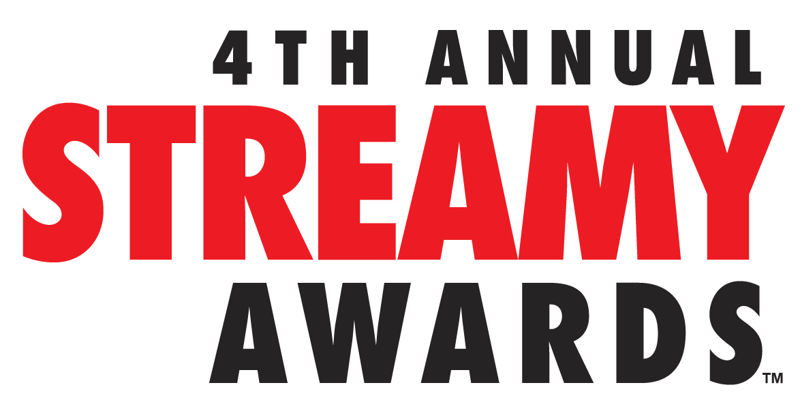

COMEDIANS GRACE HELBIG AND HANNAH HART TO HOST THE 4TH ANNUAL STREAMY AWARDS PRESENTED BY COCA-COLA

Streamys Audience Choice Awards Finalists Announced; Voting Begins Today

Show to Stream LIVE on Sunday, September 7, 2014 from The Beverly Hilton
at 7:30 PM PT at www.streamys.org

SANTA MONICA, CA (August 27, 2014) – dick clark productions and Tubefilter announced today that leading YouTube comedians Grace Helbig and Hannah Hart will host the 4th Annual Streamy Awards Presented by Coca-Cola, which will stream LIVE from The Beverly Hilton in Beverly Hills, California on Sunday, September 7, 2014 at 7:30 PM PT at www.streamys.org.

Grace Helbig, best known for her it’sGrace YouTube Channel which reaches 1.8 million viewers, previously created the My Damn Channel web series DailyGrace and has an international live tour called “#NoFilter.” Most recently, Helbig secured a comedy/talk show pilot for the cable network E!

New York Times bestselling author Hannah Hart is the creator behind the MyHarto YouTube channel, which draws more than 1.3 million subscribers to watch her intoxicating recipes and quirky food concoctions. Helbig and Hart recently starred together in the indie feature Camp Takota.

“The Streamys will be filled with memorable moments, show-stopping performances, and plenty of surprises,” Grace Helbig and Hannah Hart jointly stated (in unison). “We’re overjoyed about hosting this year’s show together and spotlighting our talented peers who are ushering digital entertainment into the mainstream.”

Executive producer Assaf Blecher added, “Grace and Hannah are two talents that truly embody the hard work and success of today’s digital age. There is no better team to co-host the show, and we couldn’t be more excited to watch their comedic talents collide.”

Also announced are the finalists for the Streamys Audience Choice Awards:

Streamys Entertainer of the Year
Bethany Mota
Brittany Furlan
Grace Helbig
Jack Vale
Jenna Marbles
Maiah Ocando
Michelle Phan
Ryan Higa
Toby Turner
Tyler Oakley

Streamys Show of the Year
Emma Approved
EnchufeTV
Kids React
MyMusic
Nerdy Nummies
Rooster Teeth
SortedFood
SourceFed
The Philip DeFranco Show
Video Game High School

Starting today, fans worldwide can vote online at www.streamys.org for their favorite entertainer and show once a day up until moments before the winners are revealed live on stage.

Fourteen awards will be presented live at the 4th Annual Streamy Awards Presented by Coca-Cola. Winners from the remaining categories will be announced prior at the Official Streamys Nominee Reception on Thursday, September 4 at YouTube Space LA in Playa Vista, California. All Streamys winners will be recognized in the September 7 live show.

The following awards will be presented live at the Streamys on Sunday, September 7, 2014 at 7:30 PM PT at www.streamys.org:

Action or Sci-Fi
Beauty
Comedy
Drama
Ensemble Cast
Fashion
First Person
Gaming
Kids and Family
News and Current Events
Original Song
Viner of the Year
Audience Choice - Entertainer of the Year
Audience Choice - Show of the Year

The 4th Annual Streamy Awards Presented by Coca-Cola are produced by dick clark productions. Blecher, Vice President of Programming and Development at dick clark productions, and Drew Baldwin and Joshua Cohen, co-founders of Tubefilter, are Executive Producers.

Last year’s 3rd Annual Streamy Awards Presented by Coca-Cola garnered over 7MM live and VOD views, and with 2.1MM Twitter timeline impressions, the Streamys was a worldwide trending topic on Twitter throughout the entire live stream. The two-hour live show featured the biggest names on YouTube and social media. The Streamy Awards was a Primetime Emmy Award Finalist and a Telly Awards Winner.

About The Streamy Awards
The Streamy Awards honor the best in online video and the creators behind it. The annual event brings together the biggest names in YouTube and online video for a night of celebration, discovery, and meaningful recognition.

About dick clark productions
dick clark productions (dcp) is among the world's largest producers and proprietors of televised live event programming. dcp produces perennial hits such as the "American Music Awards," "Golden Globe Awards," "Academy of Country Music Awards," "Billboard Music Awards," and "Dick Clark's New Year's Rockin' Eve with Ryan Seacrest." Weekly television programming, includes "So You Think You Can Dance" from 19 Entertainment, a division of CORE Media Group, and dick clark productions; as well as "Rising Star" and the upcoming “Boom!” from Keshet DCP, the joint venture between Keshet International (KI), the global distribution and production arm of Keshet Media Group, and DC Media, the parent company of dick clark productions (dcp). In 2014, dcp will debut the "American Country Countdown Awards" (FOX), “Hollywood Film Awards (CBS) and "The PEOPLE MAGAZINE Awards" (NBC). dcp also owns one of the world's mostunique and extensive entertainment archive libraries with more than 55 years of dcp's award-winning shows, historic programs, specials, performances, and legendary programming. For additional information, visit www.dickclark.com.
About Tubefilter
Tubefilter is the leading source for YouTube and online video industry news, reviews, and events. For additional information, visit www.tubefilter.comand follow @tubefilter on Twitter.
###

