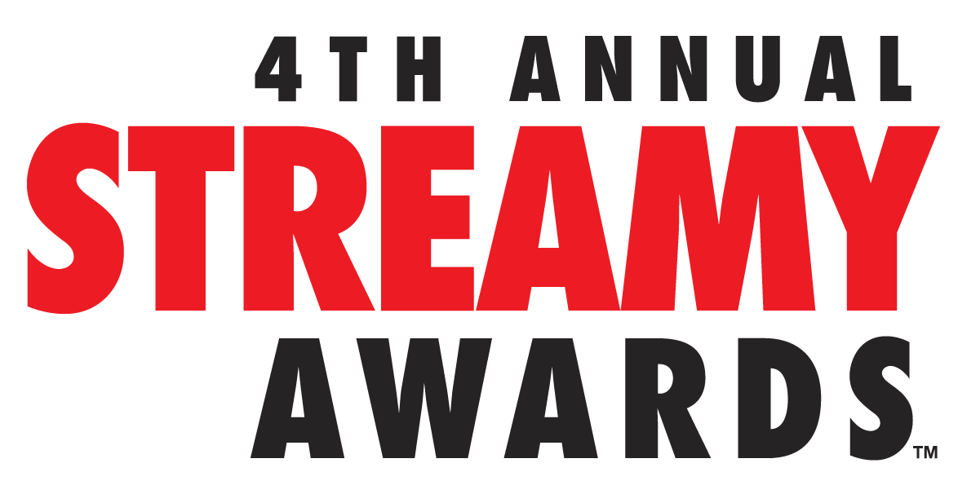

PITBULL, TYLER OAKLEY, MICHELLE PHAN, SHAY CARL TO RECEIVE FIRST EVER STREAMYS ICON AWARDS PRESENTED BY SAMSUNG

The 4th Annual Streamy Awards Presented by Coca-Cola to Stream LIVE on Sunday, September 7, 2014 from The Beverly Hilton
at 7:30 PM PT/10:30 PM ET at www.streamys.org

US THE DUO Scheduled To Perform at VIP Event Honoring Recipients

SANTA MONICA, CA (September 3, 2014) – dick clark productions and Tubefilter announced today that leading entertainers Pitbull, Tyler Oakley, Michelle Phan, and Shay Carl will receive the first-ever Streamys ICON Awards presented by Samsung at the 4th Annual Streamy Awards Presented by Coca-Cola. The Streamy ICON Awards recognize the accomplishments of remarkable individuals who have demonstrated true leadership in online video and entertainment. The 2014 show will stream LIVE from The Beverly Hilton in Beverly Hills, California on Sunday, September 7, 2014 at 7:30 PM PT/10:30 PM ET at www.streamys.org with hosts Grace Helbig and Hannah Hart.

“The Streamys have always honored emerging talent in the online video community, but this year, these innovators have engaged audiences with their creativity and impacted the zeitgeist like never before,” said Michael Mahan, President of dick clark productions. “It’s my honor to recognize Pitbull, Tyler Oakley, Michelle Phan, and Shay Carl with the inaugural Streamys ICON Awards Presented by Samsung for their accomplishments and social influence in online video and entertainment.”

Drew Baldwin Streamy Awards Executive Producer and co-founder of Tubefilter added “The Streamys ICON Award is the Streamy Awards’ highest honor, recognizing the creators who have made tremendous contributions to their communities through online video and social media.”

The inaugural Streamys ICON Awards will honor talent in four categories: Activism, Convergence, Entrepreneurship, and Inspiration, and include:

- Activism: Tyler Oakley Established as the biggest LGBT vlogger in the digital space, Tyler’s “It Gets Better” anti-bullying campaign became a global phenomenon, truly embodying social media for social good. His work with The Trevor Project has helped the organization raise over a half a million dollars, making him their highest individual fundraiser to date. His humor, talent, and devotion to pop culture have captured the hearts of a global audience—since posting his first video in 2007, Tyler’s channel has received more than 250 million views and 5.3 million subscribers, as well as two Teen Choice Awards. Tyler now appears as a regular correspondent for award shows and entertainment events, and hosts his own weekly podcast, “Psychobabble."

- Convergence: Pitbull No other artist in the world better represents the current convergence of digital and traditional media than Armando Christian Pérez, aka Pitbull. He's a globally successful musician, performer, business entrepreneur, fashion icon and actor whose career sales have exceeded 5 million albums and over 60 million singles worldwide. Pitbull has had #1 hits in more than 15 countries, his videos have over 5 billion views, and his social reach matches audiences of some television networks around the world. Pitbull also inked an exclusive overall deal with Endemol North America, creating his own production company Honey I’m Home. The two will develop and produce original content for television and the digital platform. He also played a critical role in launching the burgeoning tech and entertainment Emerge Americas conference in Miami, which he coined Silicon Paradise all that clearly define Pitbull as Mr. Worldwide.

- Entrepreneurship: Shay Carl Since Shay Butler, better known to fans as Shay Carl, joined the YouTube platform, he and his family have won the hearts of millions with their daily adventures on his SHAYTARDS YouTube channel. Shay was one of the first creators to risk turning online video into a full-time job, moving from Idaho to Los Angeles to build his own media empire. His entrepreneurial spirit created a community and a way of life that has become the foundation for the Streamy Awards. As a co-founding talent of Maker Studios, he ushered in the next-generation of digital artists helping to create a talent-first network that the traditional entertainment industry could no longer ignore. In March 2014, The Walt Disney Company acquired Maker Studios, setting a tremendous precedent in YouTube and online video history.

- Inspiration: Michelle Phan Michelle Phan is the quintessential digital pioneer who trail-blazed her way in the world of fashion and beauty on YouTube. With a growing global community of more than 6 million subscribers and recently achieving 1 billion views, Michelle has touched the lives of beauty enthusiasts around the world with more than 300 video tutorials and content. Recently, Michelle also signed an exclusive deal with Endemol Beyond USA to develop and produce original digital content. In August 2013, Michelle and L'Oréal launched em michelle phan, the first makeup line co-created by Michelle Phan and her community of beauty enthusiasts. Michelle is the Founder & Executive Producer for FAWN (For All Women Network), a women’s lifestyle network specializing in the development of female-focused premium content. She also co-founded ipsy, the online leader in inspiration commerce, and will release her first-ever book, Make Up: Your Life Guide to Beauty, Style, and Success in October 2014.

Recipients of the Streamys ICON Awards Presented by Samsung will be honored by their peers in the entertainment industry on the Friday night preceding the Streamy Awards. Musical sensation US THE DUO is set to perform.

In early 2014, US THE DUO vaulted to prominence via Vine. Their #6SecondCovers of Destiny’s Child and The Neighborhood songs gained major traction, but it was their medleys that launched them to stardom on the platform. Their mash-ups of Taylor Swift and Katy Perry songs caught the attention of BuzzFeed, iHeartRadio, and Business Insider and soon, their social media following grew to over 4 million. US THE DUO inked a deal with Republic Records in March 2014 making history as the first artists signed to a major label from Vine. Since then, their full-length original album, No Matter Where You Are, has reached #9 on the iTunes Pop Albums Chart, and landed Top 30 on the overall Albums Chart. The couple recently completed their first headlining tour with sold out dates throughout North America and have been featured by everybody from Good Morning America and The Today Show to Huffington Post, Yahoo! and VH1’s Big Morning Buzz.

The 4th Annual Streamy Awards Presented by Coca-Cola are produced by dick clark productions. Assaf Blecher, Vice President of Programming and Development at dick clark productions, and Drew Baldwin and Joshua Cohen, co-founders of Tubefilter, are Executive Producers.

About The Streamy Awards
The Streamy Awards honor the best in online video and the creators behind it. The annual event brings together the biggest names in YouTube and online video for a night of celebration, discovery, and meaningful recognition.

About dick clark productions
dick clark productions (dcp) is among the world's largest producers and proprietors of televised live event programming. dcp produces perennial hits such as the "American Music Awards," "Golden Globe Awards," "Academy of Country Music Awards," "Billboard Music Awards," and "Dick Clark's New Year's Rockin' Eve with Ryan Seacrest." Weekly television programming, includes "So You Think You Can Dance" from 19 Entertainment, a division of CORE Media Group, and dick clark productions; as well as "Rising Star" and the upcoming “Boom!” from Keshet DCP, the joint venture between Keshet International (KI), the global distribution and production arm of Keshet Media Group, and DC Media, the parent company of dick clark productions (dcp). In 2014, dcp will debut the "American Country Countdown Awards" (FOX), “Hollywood Film Awards (CBS) and "The PEOPLE MAGAZINE Awards" (NBC). dcp also owns one of the world's most unique and extensive entertainment archive libraries with more than 55 years of dcp's award-winning shows, historic programs, specials, performances, and legendary programming. For additional information, visit www.dickclark.com.
About Tubefilter
Tubefilter is the leading source for YouTube and online video industry news, reviews, and events. For additional information, visit www.tubefilter.comand follow @tubefilter on Twitter.
###

Media Contacts:

dick clark productions
Gina Sorial
GSorial@dickclark.com

Allison + Partners
Dana Block
Dana@allisonpr.com

