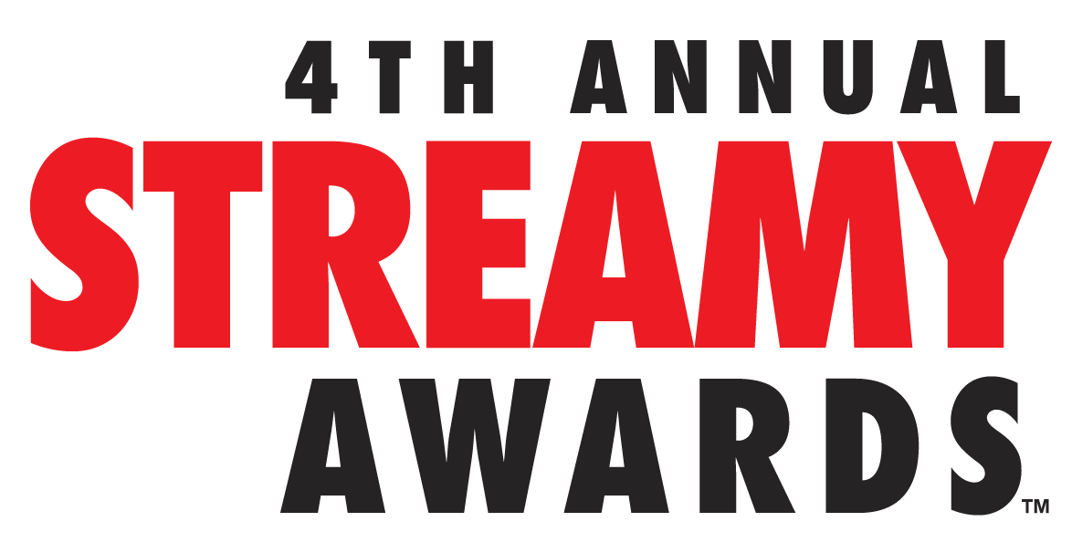
DICK CLARK PRODUCTIONS AND TUBEFILTER ANNOUNCE NOMINEES AND SHOW DATE FOR THE 4TH ANNUAL STREAMY AWARDS PRESENTED BY
COCA-COLA

Nominees Include YouTube, Vine, and Television’s Biggest Stars

To Stream LIVE on Sunday, September 7, 2014 from The Beverly Hilton
at 7:30 PM PT at www.streamys.org

SANTA MONICA, CA (August 18, 2014) – dick clark productions and Tubefilter announced today the nominees for the 4th Annual Streamy Awards Presented by Coca-Cola, which will stream LIVE from The Beverly Hilton in Beverly Hills, California on Sunday, September 7, 2014 at 7:30 PM PT at www.streamys.org. The 4th Annual Streamy Awards Presented by Coca-Cola recognizes excellence in original online video across forty-seven categories, including two Audience Choice Awards chosen entirely by members of the public.

“If the caliber of this year’s nominees is any indication, we’re on track for the biggest Streamys ever,” said Executive Producer Drew Baldwin, co-founder of Tubefilter.“ As the leading producer of live events, dick clark productions is the best possible partner for a show that honors the ever-evolving digital landscape and pioneers who are shaping the future of mainstream entertainment.”

“Without a doubt, digital video creators have become a tremendous force to inspire, educate, and entertain the public,” said Executive Producer Assaf Blecher, Vice President, Programming and Development, dick clark productions. “This year, we are introducing the Streamy ICONs, presented by Samsung, which will honor the amazing work of four industry disruptors with a spectacular and memorable moment.”
Fourteen categories will be awarded live at the 4th Annual Streamy Awards Presented by Coca-Cola. Winners from the remaining categories will be announced prior at the Official Streamys Nominee Reception on Thursday, September 4 at YouTube Space LA in Playa Vista, California. All Streamyswinners will be recognized in the September 7 live show.
New categories for the 4th Annual Streamy Awards Presented by Coca-Cola include Gaming, Beauty, Sports, Pranks, Science and Education, Kids and Family, Vine video, and a category recognizing traditional television shows that are “doing it right” by engaging audiences with innovative use of original online video and best practices in social media. A full list of Streamy Awards categories is available at www.streamys.org/categories.
Winners of the 4th Annual Streamy Awards Presented by Coca-Cola will again be determined by the Streamys Blue Ribbon Panel, a judging body of creators, executives, and other experts in the online video industry.
Last year’s 3rd Annual Streamy Awards Presented by Coca-Cola garnered over 7MM live and VOD views, and with 2.1MM Twitter timeline impressions, the Streamys was a worldwide trending topic on Twitter throughout the entire live stream. The two-hour live show featured the biggest names on YouTube and social media. The Streamy Awards was a Primetime Emmy Award Finalist and a Telly Awards Winner.
The 4th Annual Streamy Awards Presented by Coca-Cola are produced by dick clark productions. Blecher, Baldwin, and Joshua Cohen, co-founder of Tubefilter, are Executive Producers.

The complete list of nominees for the 4th Annual Streamy Awards Presented by Coca-Cola can be found below.

About The Streamy Awards
The Streamy Awards honor the best in online video and the creators behind it. The annual event brings together the biggest names in YouTube and online video for a night of celebration, discovery, and meaningful recognition.

About dick clark productions
dick clark productions (dcp) is among the world's largest producers and proprietors of televised live event programming. dcp produces perennial hits such as the "American Music Awards," "Golden Globe Awards," "Academy of Country Music Awards," "Billboard Music Awards," and "Dick Clark's New Year's Rockin' Eve with Ryan Seacrest." Weekly television programming, includes "So You Think You Can Dance" from 19 Entertainment, a division of CORE Media Group, and dick clark productions; as well as "Rising Star" and the upcoming “Boom!” from Keshet DCP, the joint venture between Keshet International (KI), the global distribution and production arm of Keshet Media Group, and DC Media, the parent company of dick clark productions (dcp). In 2014, dcp will debut the "American Country Countdown Awards" (FOX), “Hollywood Film Awards (CBS) and "The PEOPLE MAGAZINE Awards" (NBC). dcp also owns one of the world's mostunique and extensive entertainment archive libraries with more than 55 years of dcp's award-winning shows, historic programs, specials, performances, and legendary programming. For additional information, visit www.dickclark.com.
About Tubefilter
Tubefilter is the leading source for YouTube and online video industry news, reviews, and events. For additional information, visit www.tubefilter.com and follow @tubefilter on Twitter.
STREAMY AWARDS 2014 OFFICIAL NOMINEES:

Channel, Show, or Series – Overall

Comedy
Jenna Marbles
My Drunk Kitchen
MyMusic
Ryan Higa
Smosh

Companion
Almost Royal Goes To YouTube
Parks and Recreation in Europe
Prarie Home Companion Tailgating (Portlandia)
Sesame Street
Vandaveon and Mike (Key and Peele)

Drama
Chosen
Lauren
Mortal Kombat: Legacy II
Storytellers
The Lizzie Bennet Diaries

Non-Fiction or Reality
@SummerBreak
Comedians in Cars Getting Coffee
Our2ndLife
PBS Idea Channel
Shaytards

Channel, Show, or Series – Subject

Action and Sci-Fi
Action Movie Kid
Corridor Digital
Mortal Kombat: Legacy II
Red vs. Blue
Video Game High School

Beauty
Cute Polish
eleventhgorgeous
Kandee Johnson
Michelle Phan
Missglamorazzi

Dance
Break'n Reality
Dance Showdown
Jabbawockeez
Strictly Ballet
WHZGUD2

Fashion
Bethany Mota
Intersection
Lauren Curtis
MaiahOcando
Zoella

Food and Cuisine
Anthony Eats America
Epic Meal Time
Nerdy Nummies
SortedFood
Thristy For...

Gaming
PewDiePie
Smosh Games
SourceFed Nerd
Stampylonghead
TableTop

Health and Wellness
Blogilates
BroScienceLife
Kali Muscle
strengthcamp
Tony Horton Fitness

Kids and Family
Convos With My 2-Year-Old
Fatherhood
Kid President
Kids React
Shaytards

News and Current Events
Huffpost Live
Op-Docs
RetroReport
SourceFed
YouTube Nation

Pranks
FouseyTube
JackValeFilms
Prank it FWD
Roman Atwood
Stuart Edge

Science and Education
AsapSCIENCE
Good Mythical Morning
Mental Floss
The Slow Mo Guys
Vsauce

Sports
Devinsupertramp
Dude Perfect
ESPN 30 for 30
My Ink
Red Bull

Special

Animated
8-Bit Cinema
Blank on Blank
Bravest Warriors
RWBY
Simon's Cat

First Person
Grace Helbig
JennaMarbles
Justine Ezarik
MaiahOcando
Tyler Oakley

Indie
Bad Timing
Destroy The Alpha Gammas
Little Horribles
Sad Motivator
The Platoon of Power Squadron

International
AlaaWardi(Saudi Arabia)
EnchufeTV (Ecuador)
Galo Frito (Brazil)
Neymar Jr: Life Outside the Fields (Brazil)
Noob (France)

Performance

Actress in a Comedy
Johanna Braddy, Video Game High School
Brittany Furlan, SHFTY ~ Super Happy Fun Time, Yay!
Mamrie Hart, You Deserve A Drink
Charlotte Newhouse, Idiotsitter
Joanna Sotomura, Emma Approved

Actress in a Drama
TroianBellisario, Lauren
Ashley Clements, The Lizzie Bennet Diaries
Kate Conway, Out With Dad
Francesca Eastwood, Oh, You Pretty Things!
Julia Stiles, Blue

Actor in a Comedy
Brent Bailey, Emma Approved
Klarity, SHFTY ~ Super Happy Fun Time, Yay!
David Milchard, Convos With My 2-Year-Old
Paul Scheer, ArScheerio Paul
Jimmy Wong, Video Game High School

Actor in a Drama
David Arquette, Cleaners
Wilson Cleveland, BlackBoxTV Presents
Joey Graceffa, Storytellers
Brian Tee, Mortal Kombat: Legacy II
Daniel Vincent Gordh, The Lizzie Bennet Diaries

Collaboration
Flula Borg and Chester See,Flula
Zach Galifianakis and President Barack Obama, Between Two Ferns
Harley Morenstein and Arnold Schwarzenegger, Epic Meal Time
Nice Peter, EpicLLOYD, and Snoop Dogg, Epic Rap Battles of History
Rooster Teeth, Freddie Wong, iJustine, Greg Miller, and Adam Kovic, The Gauntlet: Season 2

Ensemble Cast
ArScheerio Paul
MyMusic
Next Time On Lonny
The Annoying Orange
Video Game High School

Music

Cover Song
Andy Lange, Chester See, Andrew Garcia, and Josh Golden, Roar (Katy Perry)
Madilyn Bailey, Wake Me Up (Avicii)
Pentatonix, Daft Punk Mashup (Daft Punk)
Pomplamoose, Happy/Get Lucky Mashup (Pharrell Williams)
Postmodern Jukebox, Timber (Pitbull ft. Ke$ha)

Music Video
#SELFIE, The Chainsmokers
Cookie Dance, Chip Chocolate
Finish What We Started, Miles Fisher
Goku vs Superman, Epic Rap Battles of History
Odds Are, Barenaked Ladies

Musical Artist
Boyce Avenue
Chester See
Cimorelli
Lindsey Stirling
Pentatonix

Original Song
#LEH, Superwoman and Humble The Poet
Airplanes and Terminals, Timothy DeLaGhetto
Love Again, Pentatonix
Never Wanna Let You Go,Megan Nicole
Whistle While I Work It, Chester See

Craft

Choreography
Castrol Footkhana: Neymar Jr. v Ken Block, Andy Ansah, Neymar Jr., and Ken Block
Dance Showdown, Ambrose Respicio and AnzeSkrube
Jabbawockeez Presents Regenerate, Jabbawockeez
Mortal Kombat: Legacy II, Garrett Warren and Larnell Stovall
Super Power Beat Down, Alvin J. Hsing and Shaun Paul Piccinino

Cinematography
@SummerBreak, Joseph Guidry
Devinsupertramp , Devin Graham
Mortal Kombat: Legacy II, Scott Keven
Making A Scene, BartoszNalazek
Rocket Jump, John Salmon

Costume Design
Bart Baker, Morgan Christensen and Amanda Hosler
Epic Rap Battles of History, Sulai Lopez
Fallout: Nuka Break, Katie Broad
Video Game High School, Regina Amato, Christina Matthews, Imari Tucker
YouTube Rewind, Annie Rothschild

Directing
BlackBoxTV Presents, Tony E. Valenzuela
Eric Wareheim, Eric Wareheim
Lauren, Jon Avnet
Mortal Kombat: Legacy II, Kevin Tancharoen
Video Game High School, Freddie Wong

Editing
Epic Rap Battles of History, Andrew Sherman, Ryan Moulton, Daniel Turcan, Nice Peter, and Joseph Shahood
Kids React, Dan Seibert, Justin Reager, Benny Fine, Rafi Fine, Jordan Towles
MysteryGuitarMan, Joe Penna, Ryan Morrison
Rocket Jump, Freddie Wong
The Annoying Orange, Dane Boedigheimer, Aaron Massey, Spencer Grove, Matt Sklar

Original Score
Caper, Joe Loduca
Continuum, Damon Criswell
Next Time On Lonny, Leo Birenberg
Red Scare, GionaOstinelli
RWBY, Jeff Williams

Visual and Special Effects
Action Movie Kid, Daniel Hashimoto
Corridor Digital, Niko Pueringer and Sam Gorski
Mortal Kombat: Legacy II, Lars Anderson
Rocket Jump, Freddie Wong
Video Game High School, Chris Bailey and Joseph Cornell

Writing
Barely Political, Mark Douglas and Todd Womack
Epic Rap Battles of History, Nice Peter, EpicLLOYD, Zach Sherwin, Dante Cimadamore, and Mike Betette
Husbands, Brad Bell and Jane Espenson
Kid President, Brad Montague and Robby Novak
Red vs. Blue, Burnie Burns and Miles Luna

Vine

Vine Comedian
Alphacat
Brittany Furlan
DeStorm Power
Jerome Jarre
Logan Paul

Vine Creativity
Mashable
Meagan Cignoli
Regal Cinemas
yelldesign
Zach King

Viner of the Year
Brittany Furlan
Cameron Dallas
King Bach
Lele Pons
Marcus Johns

Campaign or Event

Brand Campaign
Backseat Italians (Fiat)
Dear Kitten (Purina Friskies)
Need For Speed: Ken Block’s Gymkhana Six (Need For Speed)
Sloth Week (Animalist)
Superman With a Go Pro (Go Pro)

Live Event
#Tubeathon 2013
Comedy Gives Back 2013
DigiFest NYC 2014
Doctor Who 50th Anniversary Live
Steve Aoki: Live at the Shrine

Public Service
International Day of Happiness
Rooster Teeth 24 Hr Extra Life Fundraiser
Sport Relief 2014
Star Wars: Force for Change
YouTube Stars Talk Health Care at the White House

Television

Television Show
@midnight
Conan
Jimmy Kimmel Live
Right This Minute
Tonight Show Starring Jimmy Fallon

###

