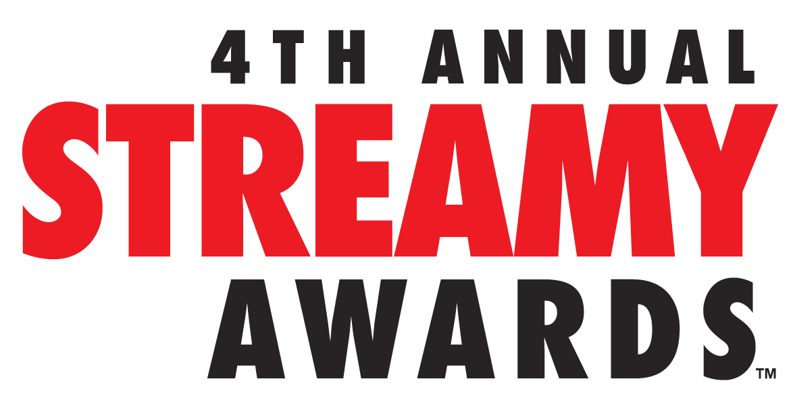
4th ANNUAL STREAMY AWARDS OPEN SUBMISSIONS WITH
NEW AWARDS, NEW STREAMLINED ENTRY, AND NEW
NOMINATIONS & VOTING PROCESS
LOS ANGELES, CA July 9, 2014 – The 4th Annual Streamy Awards is now accepting submissions. Honoring excellence in online video and those who create it, the 4th Annual Streamy Awards will reflect the current state of original programming native to YouTube and online video with the addition of subject awards as well as Vine and television awards. To ensure the broadest participation by the YouTube and online video community, the official entry process has been streamlined. Fans will be responsible for selecting one of the five nominees in each awards category.

Submissions open today at http://www.streamys.org and close 11:59 pm PT on Sunday, July 27, 2014.

“This year has proved that online is the place to be—for both creators and audiences alike—as original online programming continues to soar to new heights,” Streamy Awards Executive Producer Drew Baldwin. “The Streamy Awards are about relevance, excellence, and diversity, which is why our new categories reflect the current state of the industry and embrace the incredible enthusiasm and engagement of the online video community.”

New awards include:
- All-new subject awards, including Gaming, Beauty, Sports, Pranks, Science and Education, and Kids and Family, among others.
- Three awards devoted to Vine: Comedian, Creativity, and Viner of the Year.
- New awards that reflect emerging YouTube trends: Collaboration, Public Service, Cover Song, Indie, and First-Person series.
- A television award recognizing traditional television shows that are “doing it right” by engaging audiences with innovative use of original online video and best practices in social media.

The full list of categories for the 4th Annual Streamy Awards is available at www.streamys.org/categories.
Recognizing the important role that audiences play in the online community, the Streamys are putting fan participation at the heart of official nominations process. Fans are allowed to publicly nominate their favorite creators or programs across official Streamy Awards categories (with the exception of craft categories) at www.streamys.org. The entrant in each category with the most fan submissions will automatically become one of the five official nominees in each category.

“YouTube’s mega-influencers are now becoming household names, and audience engagement plays a critical role in their success,” said Streamy Awards Executive Producer Joshua Cohen. “Fans are a major component of the Streamys nominations process because they are part of online video’s DNA.”

Streamys winners are determined by the Streamys Blue Ribbon Panel, comprised of a select group of leaders shaping the future of entertainment. They include creators, executives, and other experts in the online video industry.

Last year’s 3rd Annual Streamy Awards garnered over 7 MM live and VOD views. With 2.1 million Twitter timeline impressions, the Streamys was a worldwide trending topic on Twitter throughout the entire live stream, beating out the NBA All-Star Game. The two-hour live show featured the biggest names on YouTube and social media and was a Primetime Emmy Award Finalist and a Telly Awards Winner. The 4th Annual Streamy Awards will be live-streamed this fall from Los Angeles.

The 4th Annual Streamy Awards recognizes excellence across forty-seven categories, including two Audience Choice Awards chosen entirely by members of the public.

Channel, Show, or Series (4)
Comedy
Companion
Drama
Non-Fiction or Reality

Subject (12)
Action and Sci-Fi
Beauty
Dance
Kids and Family
Fashion
Food and Cuisine
Gaming
Health and Wellness
News and Current Events
Pranks
Science and Education
Sports
Performance (6)
Actress in a Comedy
Actress in a Drama
Actor in a Comedy
Actor in a Drama
Collaboration
Ensemble Cast

Music (4)
Cover Song
Musical Artist
Music Video
Original Song

Special (4)
Animated
First Person
Indie
International
Craft (8)
Choreography
Cinematography
Costume Design
Directing
Editing
Original Score
Visual and Special Effects
Writing

Television (1)
Television Show

Vine (3)
Vine Comedian
Vine Creativity
Viner of the Year

Campaign or Event (3)
Brand Campaign
Live Event
Public Service

Audience Choice (2)
Entertainer of the Year
Show of the Year

About The Streamy Awards
The Streamy Awards honor the best in online video and the creators behind it. The annual event brings together the biggest names in YouTube and online video for a night of celebration, discovery, and meaningful recognition.

Streamy Awards 2014 Submissions Now Open [VIDEO]
http://youtu.be/zJNCmaANq5M

Media Contacts:
Karlyn Nelson / Rachel McCallister
MPRM Communications
knelson@mprm.com / rmccallister@mprm.com
323.933.3399

